**Design Decisions Document**

**Development Choices**

For this project, I selected objects that were sitting on my desk, as I thought they would make an interesting and relatable 3D scene. The objects I chose include a snow globe, a book, a box, and a coffee mug. To model these objects, I used basic 3D shapes:

Snow Globe: Created using a tapered cylinder for the base and a sphere for the globe.

Coffee Mug: Modeled with a cylinder for the body and a torus for the handle.

Box and Book: Both were made using box meshes since they matched the simple shapes of the real-world objects.

I focused on using organized geometry to create clean and simple models while keeping the polygon count low to ensure efficiency.

**Textures**

I applied two textures to the objects in my scene: one wood texture and one brick texture. These textures were chosen because they added distinct appearances to the shapes even though the snow globe was brick I thought it was neat. The wood texture for the box also turned out really nice.

**Lighting**

Lighting was one of the most challenging aspects of this project. I attempted to implement the lighting model, incorporating ambient, diffuse, and specular components. My goal was to create a polished visualization with two light sources, one of which would be colored. However, I encountered significant challenges during the process, as the screen often turned completely black when I attempted to render the scene with lighting. Despite troubleshooting, I was unable to resolve this issue and for the final submission, I commented out the lighting code to ensure that the shapes were visible.

**Object Placement**

To position the objects I recreated the scene as it appeared on my desk. The snow globe sits on the book, with the box nearby and the coffee mug placed next to it. I adjusted the X, Y, and Z coordinates to align the objects and make the scene resemble the original setup. The placement of the torus for the coffee mug handle was particularly challenging, as I wanted it to look natural yet clearly a shape. I settled on a 45 degree rotation, which gave the handle a unique and neat appearance.

**Navigation**

The scene includes intuitive navigation controls, allowing the user to explore the 3D environment. The controls include:

W, A, S, D: Move forward, backward, left, and right, respectively.

Q and E: Move up and down.

Mouse Scroll Wheel: Adjust the speed of movement.

P and O: Toggle between 2D (orthographic) and 3D (perspective) views.

These controls provide flexibility for navigating around the objects and viewing them from different angles.

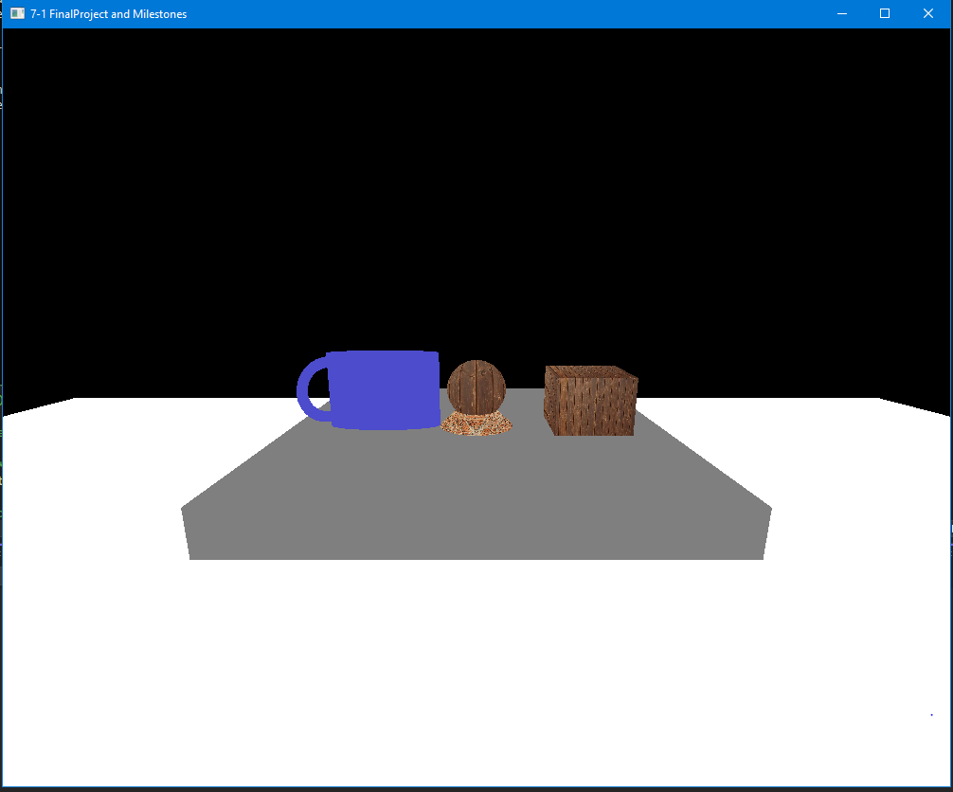The placement of shapes and the application of textures were enjoyable and worked well in recreating the scene. I found satisfaction in seeing the objects come together in a 3D environment. However, lighting posed a significant challenge. Despite my best efforts to implement ambient, diffuse, and specular lighting, I often encountered a black screen, which hindered the final visualization. I decided to comment out the lighting code to ensure the shapes could still be seen and appreciated in the final submission.

In the future, I plan to revisit the lighting process to better understand and implement it successfully. This experience has taught me a great deal about the complexity and importance of lighting in 3D graphics.